|  |
| --- |
| DEAD SHOT  [http://orig06.deviantart.net/f96f/f/2013/205/5/e/deadshot_daiquiri__by_arturo2x-d6ezqu0.png](http://www.google.ca/url?sa=i&rct=j&q=&esrc=s&source=images&cd=&cad=rja&uact=8&ved=0ahUKEwiD2oWdybTLAhWJkIMKHei1DtQQjRwIBw&url=http://pvt-arturo.deviantart.com/art/Deadshot-Daiquiri-387979416&bvm=bv.116573086,d.amc&psig=AFQjCNEnPbDZlt7zFIoS4VDWhlLlxriA1A&ust=1457646147135301) |
| Descendants of the Sun |
| **Shoot enemies** |
| Version #01  All work Copyright © 2016 by Santa’s Secret  All rights reserved. |
| **[Jiho Yoo]** |
|  |

|  |
| --- |
| March 25th 2016 |

**Table of Contents**

Table of Contents

Version History 3

Game Overview / Description 3

Game Play Mechanics 4

Camera 5

Controls 5

Interface Sketch 5

Menu and Screen Descriptions 6

Game World 7

Non-player Characters 7

Enemies 8

Characters/ Vehicles 8

Scoring 9

Sound Index 9

Art / Multimedia Index 9

# Version History

* March 10, 2016 - Set game title and guidelines

* March 15, 2016 - Game Map changed

* March 17, 2016 - Changed Screen color

* March 20, 2016 – Downloaded Zombie assets

* March 22, 2016 – Got Zombie animator

* March 25, 2016 - Got Github errors, so changed Github repo.

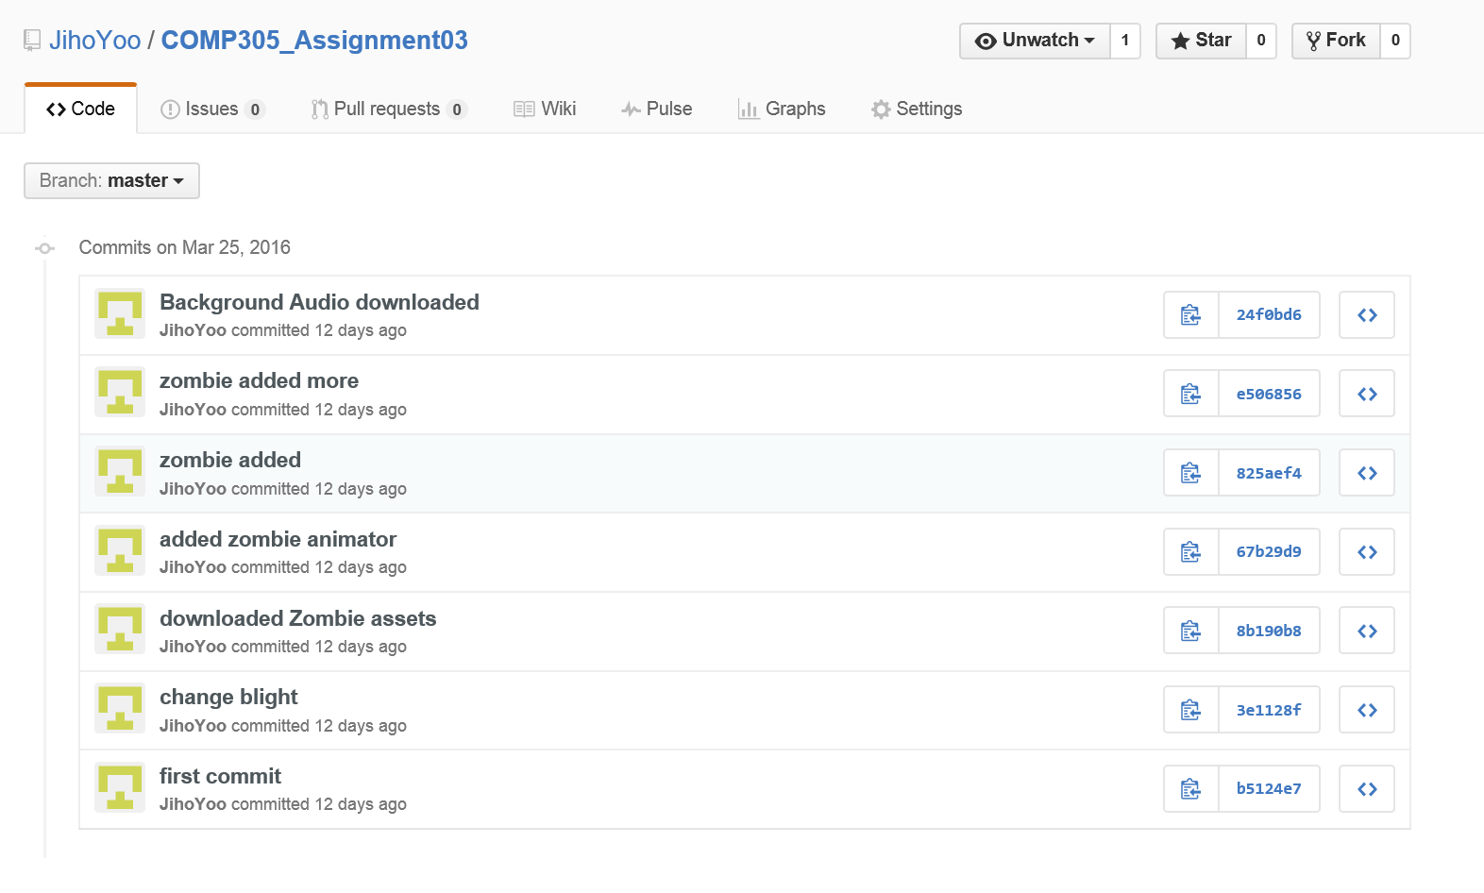

.

# Game Overview / Description

The game is 3D shooting games. A user can hit box by shooting. But the user should void zombies. If the user touch the zombies, the lives of user will be reduced. In addition, if the user hit the boxes, the user can get scores.

# Game Play Mechanics

Shoot enemies and get points by using mouse controller.

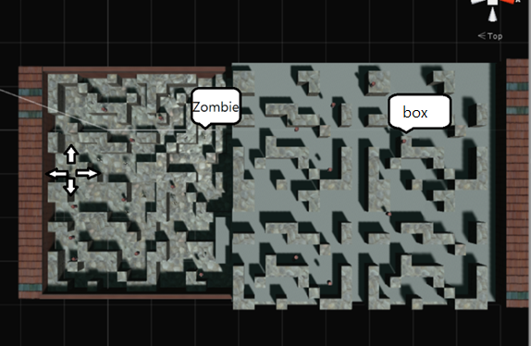

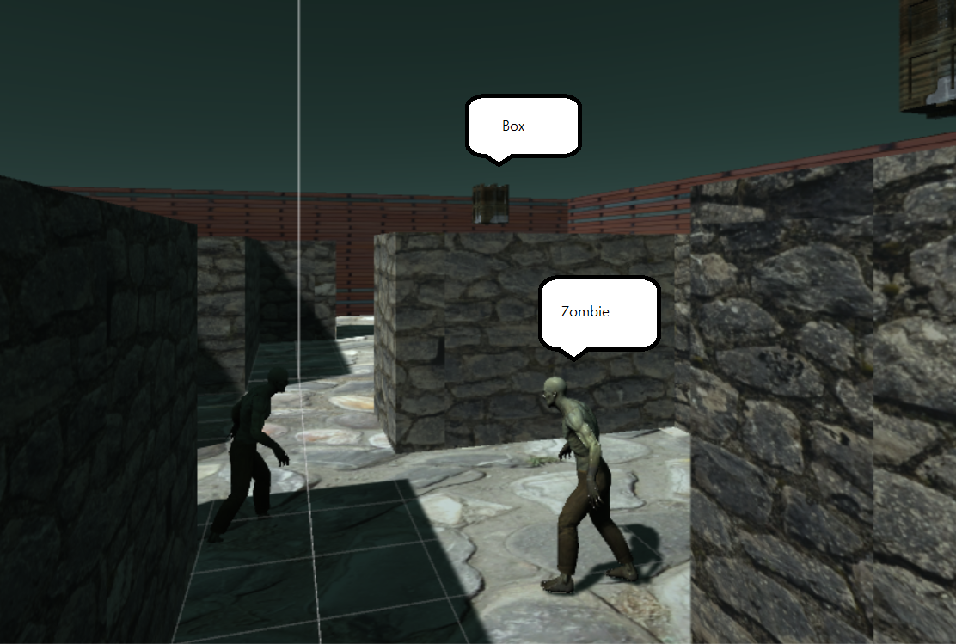

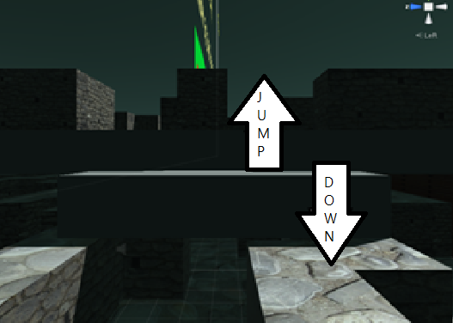

# Camera

3D (First person view)

# Controls

-Use Key board and mouse

# Interface Sketch

1. *Start scene*

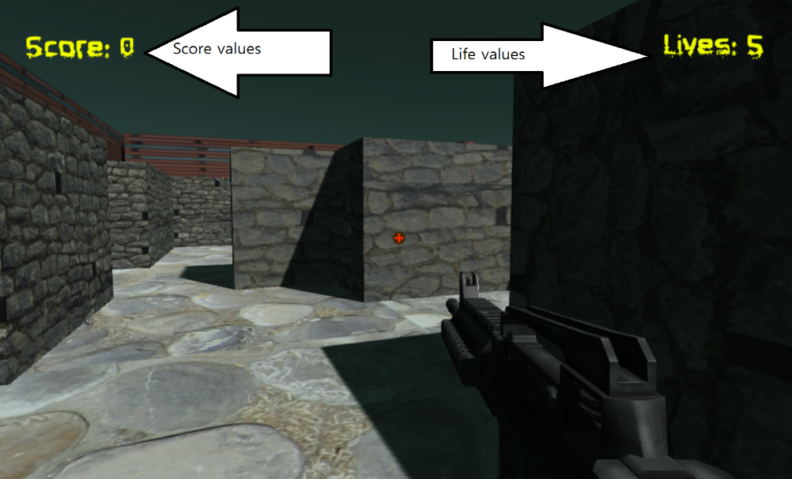

1. *End scene*

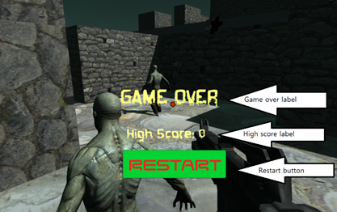

# Menu and Screen Descriptions

1. *Start scene – the user starts game with 5 lives.*

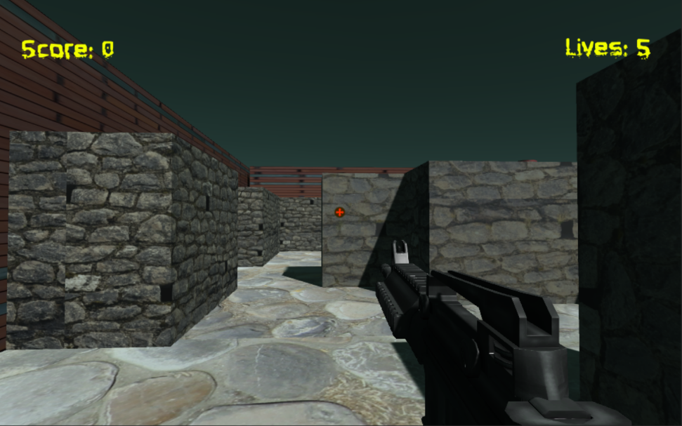

1. *Playing scene – the user can jump to stand on the bricks.*

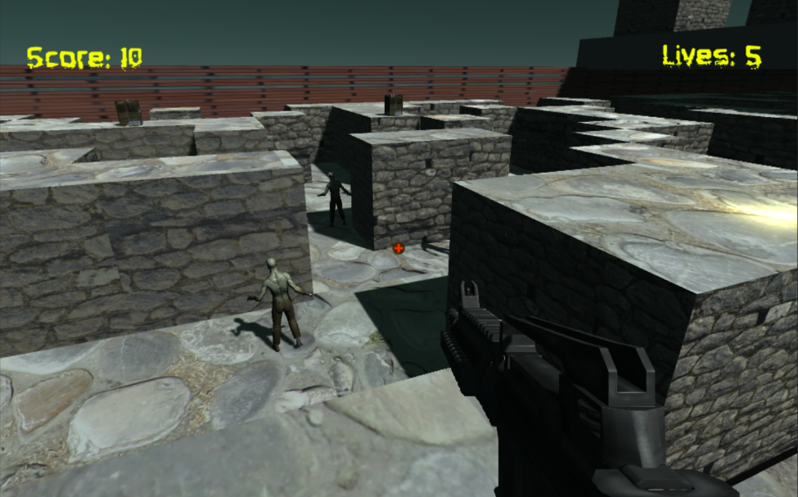

1. *End scene – when the user touch zombies 5 times.*

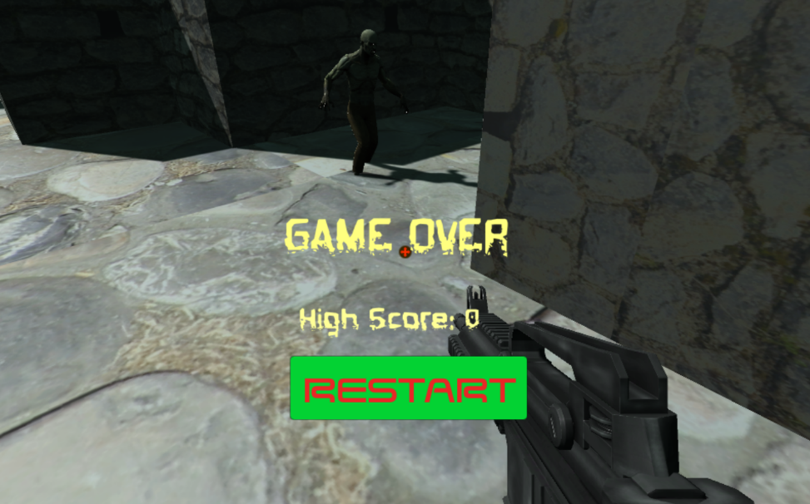

# Game World

* Dark pathway of hell.

# Non-player Characters

* Boxes

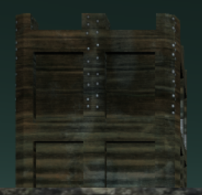

# Enemies

* Zombie / They stand on the ground with moving. If the user touch the zombie, the life values will be down.

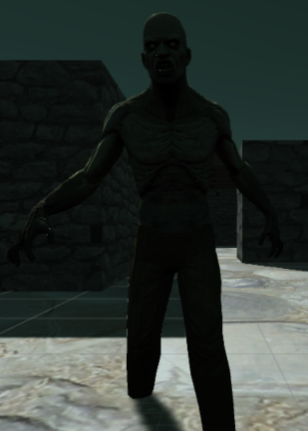

# Characters/ Vehicles

-M4A1/ The User’s gun. The user can hit boxes or zombies by using the gun.

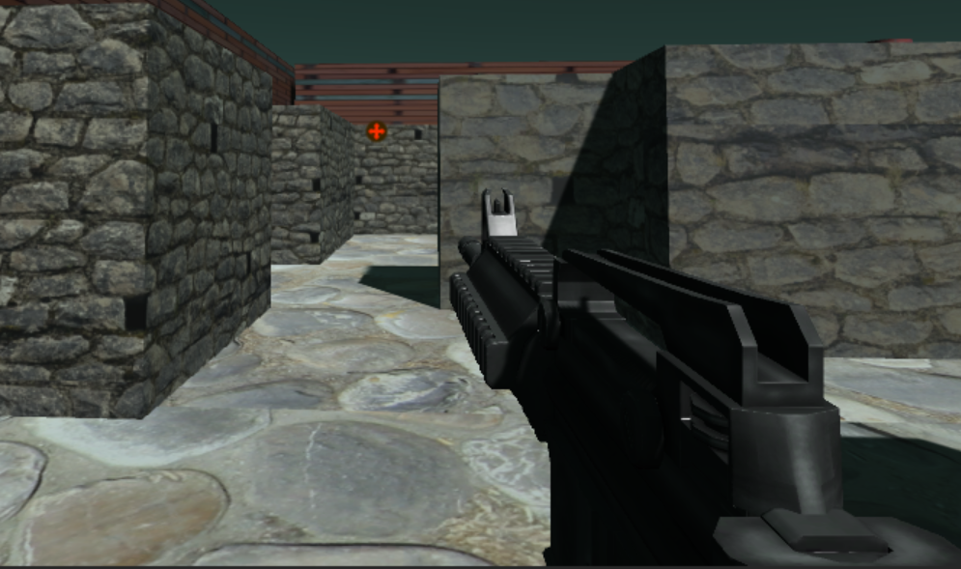

# Scoring

* If you shoot boxes, the scores are going up

# Sound Index

- Jump - Jump

- Land - Land

- Shoot - M4A1_ShortSingle

- Hit concrete - concrete-bullet-impact 3

- Hurt - flesh-impact-bullet-2

- Background - 17 Pillow talk

# Art / Multimedia Index

* *Zombie*

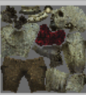

* *Explosion*

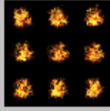

* *M4A1*

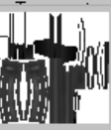

* *Box*

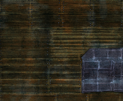

* *Brick*

**